**LAB 5: USE of Trigger**

*CREATE DATABASE LAB5*

*USE LAB5*

1. **Create a table student (sid, sname, marks, address) and studentlog (logid, sid, actiontype, actiontime)**

*CREATE TABLE student(*

*sid int primary key,*

*sname varchar(30),*

*marks int,*

*saddress varchar(40)*

*)*

*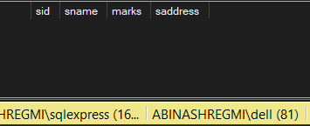Select * from student*

CREATE TABLE studentlog(

logid int identity(1,1),

sid int ,

actiontype varchar(30),

actiontime date

foreign key(sid) references student(sid)

)

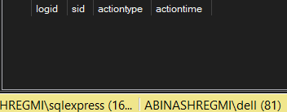select * from studentlog

1. **Create a trigger studentlog trigger in which log of student table inserted automatically when new data inserted to student table**

*CREATE TRIGGER studentlog_trigger*

*ON student*

*AFTER INSERT*

*AS*

*BEGIN*

*INSERT INTO studentlog (sid, actiontype, actiontime)*

*SELECT sid, 'INSERT', GETDATE()*

*FROM inserted;*

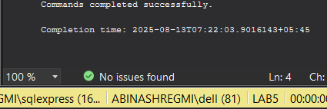*END;*

*INSERT INTO student (sid, sname, marks, saddress)*

*VALUES (2, 'Abinash', 68, 'Kathmandu');*

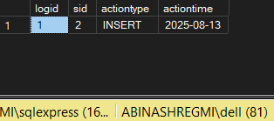*Select * from studentlog*

*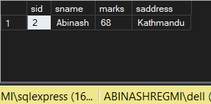Select * from student*

1. **Create a trigger ‘student_message’ after inserting dates to student table**

*CREATE TRIGGER student_message*

*ON student*

*AFTER INSERT*

*AS*

*BEGIN*

*PRINT 'New student record has been inserted into the student table.';*

*END;*

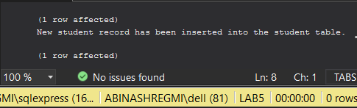

1. **Create a trigger ‘student_totalmarks”to find total marks and display it**

*CREATE TRIGGER student_totalmarks*

*ON student*

*AFTER INSERT*

*AS*

*BEGIN*

*DECLARE @total DECIMAL(10,2);*

*SELECT @total = SUM(marks)*

*FROM student;*

*PRINT 'Total marks of all students: ' + CAST(@total AS VARCHAR(20));*

*END;*

*INSERT INTO student (sid, sname, marks, saddress)*

*VALUES (10, 'Ram', 85.50, 'Kathmandu');*

